Hero Section
INDUSTRIAL AUTOMATION DIVISION

POWERING INDUSTRY.

CONTROLLING PERFORMANCE.
Industrial automation products, drive solutions and technical support for reliable motor control and industrial applications.
Authorized Distributor of Schneider Electric | Siemens | Delixi Electric
[ REQUEST A QUOTE] [ EXPLORE PRODUCTS]
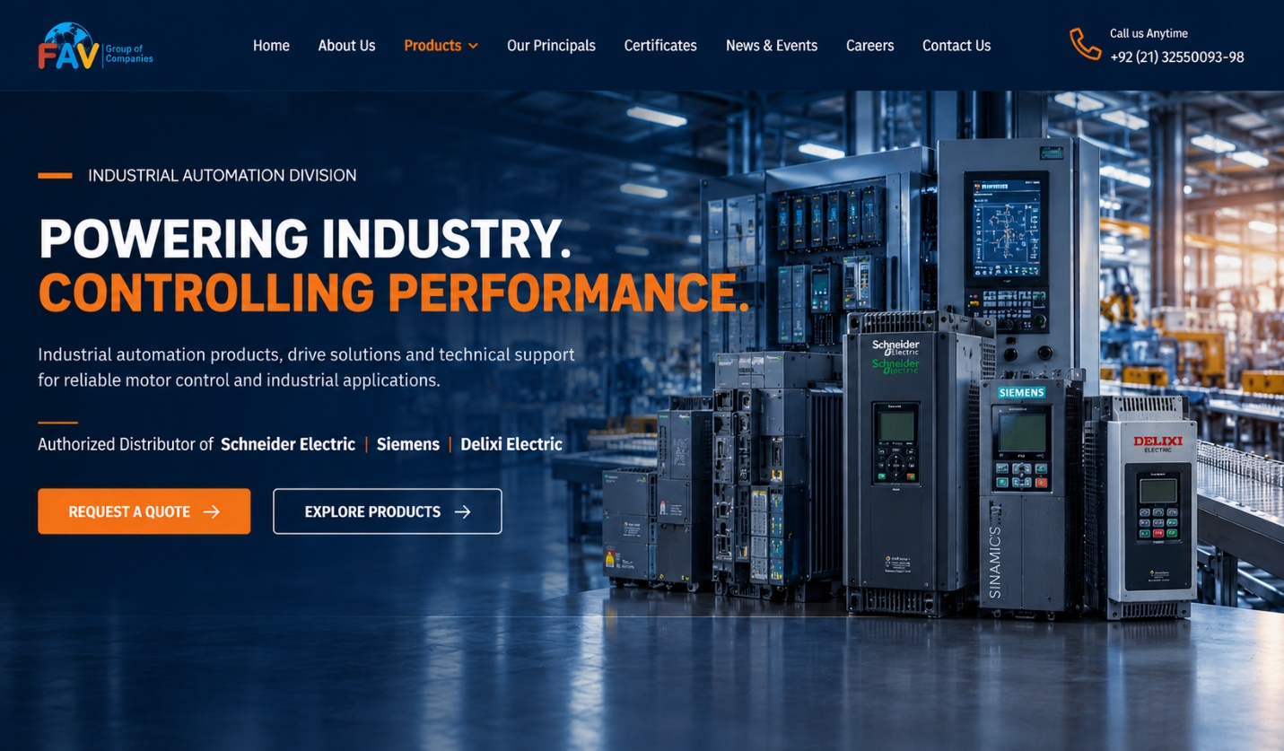
Link the “EXPLORE PRODUCTS” button to the “OUR PRODUCT CATEGORIES” section.
When users click on “EXPLORE PRODUCTS,” they should be redirected to the “OUR PRODUCT CATEGORIES” section on the same page.

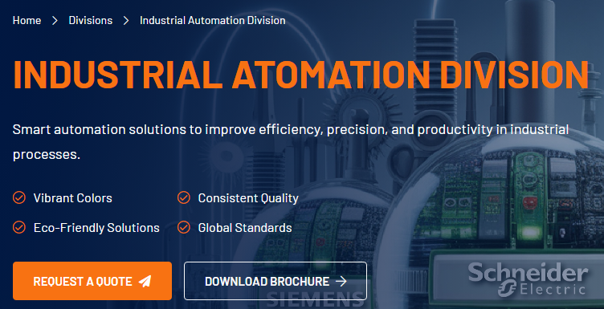Link the “REQUEST A QUOTE” button to the final “GET IN TOUCH” section.
When a user clicks on “REQUEST A QUOTE,” a new page should open displaying a form with the following details:
WHAT INFORMATION SHOULD YOU PROVIDE?
To help us prepare an accurate quotation, please provide as much of the following information as available:
Product / Model:
Quantity Required:
Motor Rating (kW / HP):
Motor Voltage (V):
Motor Current (A):
Application / Purpose:
Preferred Brand:
Required Delivery Timeline:
Company Name:
Contact Person:
Email Address:
Phone Number:
Additional Requirements / Remarks:
[ SUBMIT YOUR REQUIREMENT → ]
ABOUT OUR INDUSTRIAL AUTOMATION DIVISION
Reliable Automation Solutions for a Smarter Tomorrow
We provide a comprehensive range of industrial automation products, drive solutions and technical support to help industries improve efficiency, enhance productivity and achieve long-term performance. Our solutions are trusted by manufacturers across various industries for their reliability, innovation and support.
1. Industrial Automation Products
Complete range of VFDs, Soft Starters, PLCs, HMIs and automation components.
2. Drive Solutions
High-performance VFDs, soft starters and motor control solutions for every application.
3. Technical Support
Expert guidance at every stage from selection to commissioning.
4. Application Support
Tailored solutions for your specific industrial needs and challenges.
5. Reliable Supply
Genuine products, ready stock and on-time delivery for uninterrupted operations.
6. Customer Satisfaction
Our commitment is your success — with reliable products and dedicated support.
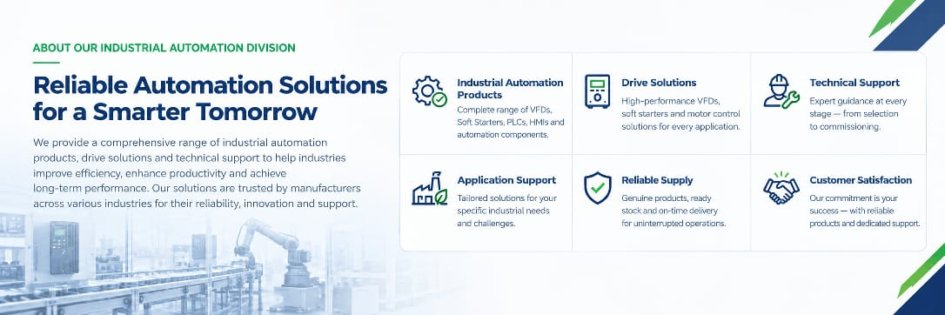

OUR PRODUCT CATEGORIES
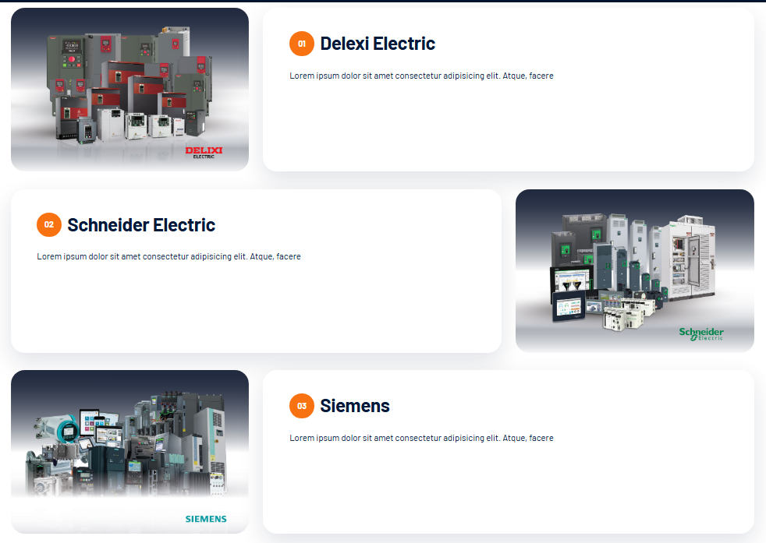
TECHNOLOGY PARTNERS
THREE GLOBAL BRANDS.
ONE INDUSTRIAL AUTOMATION PARTNER.
We work with world-leading technology partners to deliver reliable, efficient and future-ready automation solutions for your industry.
SCHNEIDER ELECTRIC
DRIVES • AUTOMATION • MOTOR CONTROL
VFDs Soft Starters PLCs HMIs

VIEW PRODUCT BROCHURE →

SIEMENS
DRIVES • AUTOMATION • MOTOR CONTROL
VFDs PLCs HMIs

VIEW PRODUCT BROCHURE →

DELIXI ELECTRIC
DRIVES • AUTOMATION • MOTOR CONTROL
VFDs SPARE PARTS

VIEW PRODUCT BROCHURE →
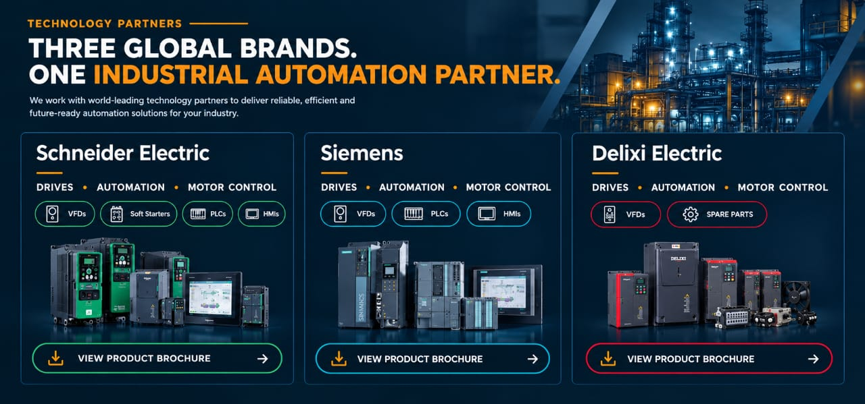

INDUSTRIES
SERVING INDUSTRIES THAT KEEP MOVING.
Automation and motor-control support across process and manufacturing environments.
Cement & Building Materials
Drive solutions for conveyors, fans, pumps and process equipment.
Water & Wastewater
Variable speed control for pumps, blowers and treatment systems.
Pharmaceutical
Motor control and automation components for manufacturing processes.
Textile
Drive and motor-control solutions for textile machinery.
Food & Beverage
Automation and motor control for production and processing equipment.
Manufacturing
Industrial drives, control products and automation components.
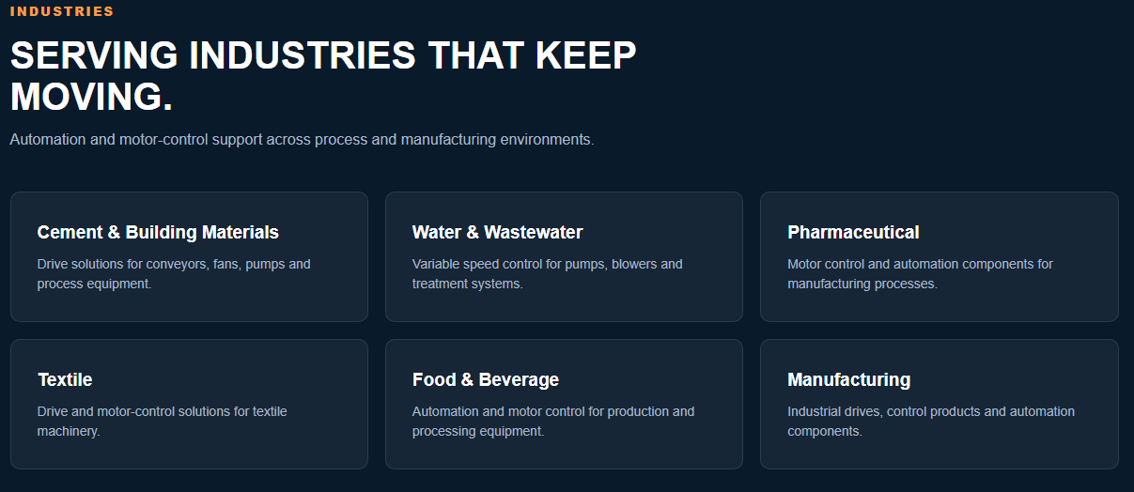

WHY CHOOSE VAWDA
Your Trusted Partner in Industrial Automation

With authorized technology partners, ready-stock products, application expertise, and technical support, Vawda provides reliable automation solutions from product selection to commissioning and maintenance.

✓ Authorized Brand Partners
Schneider Electric, Siemens & Delixi Electric
✓ Ready Stock & Genuine Products
Selected drives and automation products available from stock, subject to availability.
✓ Application & Technical Support
Assistance with product selection, drive applications and troubleshooting.
✓ Repair, Maintenance & Commissioning
VFD repair, maintenance, installation and commissioning support.
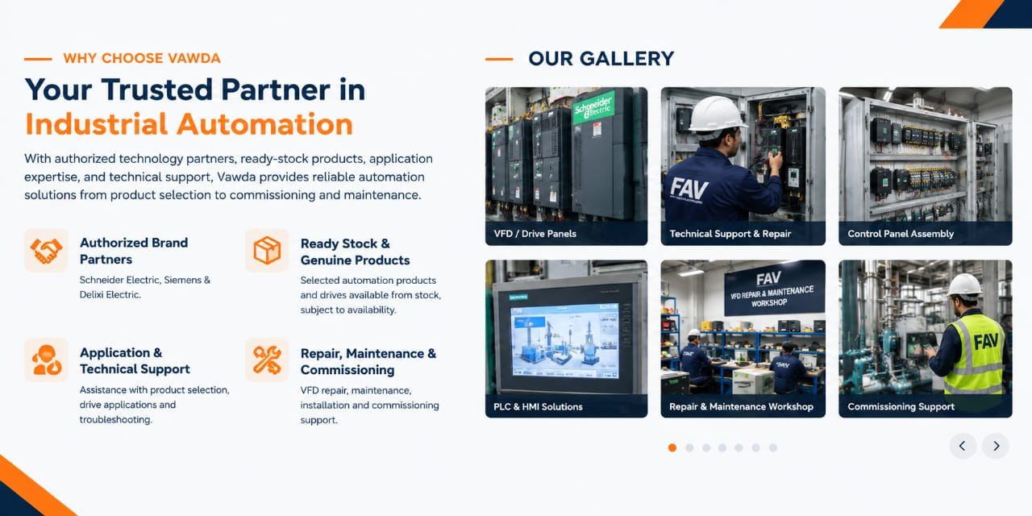

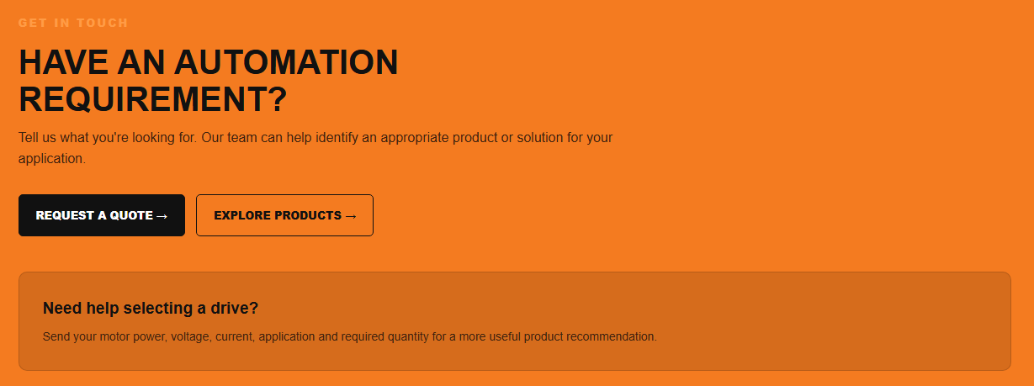
GET IN TOUCH
HAVE AN AUTOMATION REQUIREMENT?
Tell us what you're looking for. Our team can help identify an appropriate product or solution for your application.
REQUEST A QUOTE → EXPLORE PRODUCTS →

Need help selecting a drive?
Send your motor power, voltage, current, application and required quantity for a more useful product recommendation.

